**Benefits Claim**

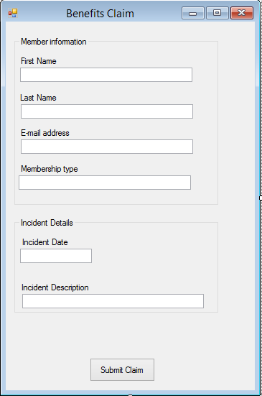

This is what the claim for benefits should look like.

**Member Poll**

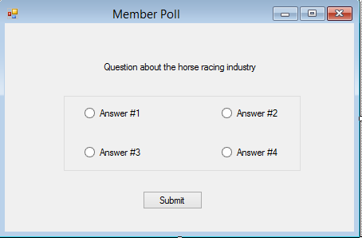

This is a vague prototype of what the member poll will look like. The amount of answers does not need to be limited to four choices. You can have as many as you see fit.

**News Feed**

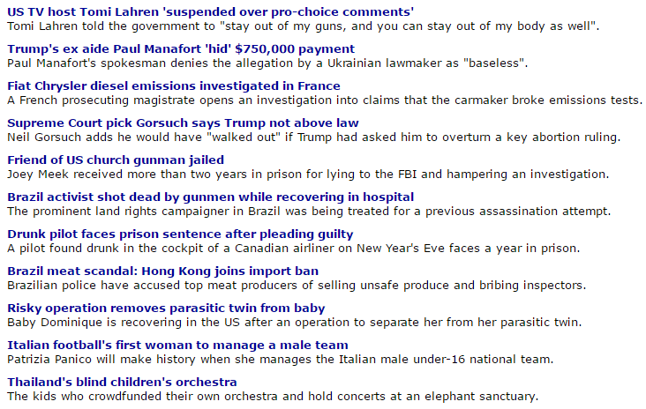

This is a rough prototype of what the news feed will look like. There will be news updates from every website that is subscribed to, here in one place.

**Employee Info Page**

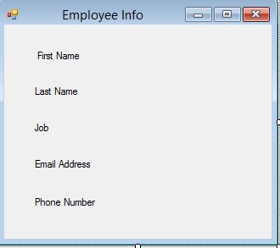

This is a very vague prototype of what the employee info page will consist of. This is the information that will be shown for all employees on this page.